3GPP TSG-RAN WG1 Meeting #125 R1-2604326
Dalian, China, May 18 – 22, 2026

Agenda item: 10.8.3
Title: Views on 6GR ISAC Waveform
Source: National Institute of Standards and Technology (NIST)
Document for: Discussion and Decision

Introduction
At 3GPP TSG RAN1#124bis, it was agreed that the 6G CP-OFDM waveform is the starting point for the 6G waveform and frame structure studies and the benchmark for evaluating the benefits of sensing waveforms. In addition, companies are encouraged to provide views on LLS, SLS, and theoretical waveform characteristics analysis to evaluate the ISAC waveform and its integration with communication. The plan for this meeting was outlined as follows [1]:

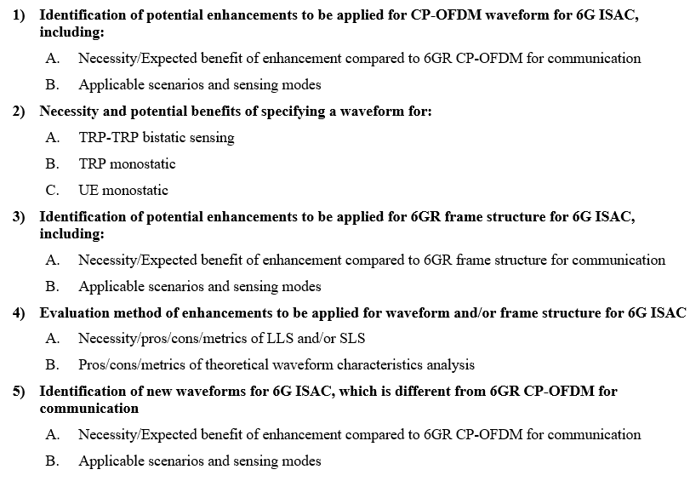

In this contribution, we share our perspective on the sensing waveform study. We also discuss link-level simulation and provide our views on channel modeling and evaluation configuration.

Sensing Waveforms
At the RAN1#124bis meeting, the following agreement has been reached [1]:
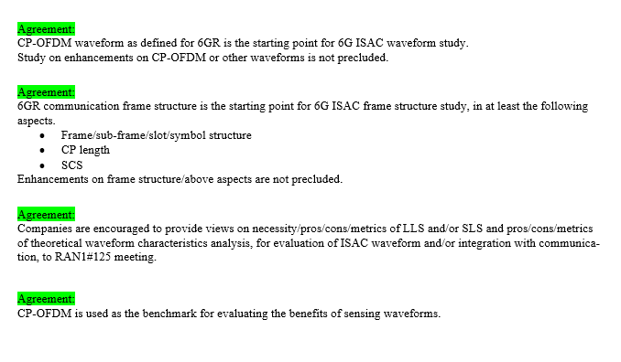

According to the agreement, the CP-OFDM waveform defined for 6GR will serve as the starting point for the 6G ISAC waveform study. CP-OFDM is the foundational waveform for 4G LTE downlink and has evolved into the industry standard for both downlink and uplink in 5G NR and Wi-Fi due to its high spectral efficiency, strong multipath mitigation, and suitability for high-capacity data transfer. While OFDM is highly effective for data transmission, the following issues could degrade sensing performance.

- Self-Interference (SI): In monostatic sensing, due to the continuous waveform, simultaneous transmission and reception can cause SI, leading to receiver saturation.
- High PAPR: The CP-OFDM signal's high PAPR reduces the maximum effective transmit power, making detection of distant or small targets more difficult.
- High Sidelobes: Compared with a radar signal, a communication signal, such as CP-OFDM, can exhibit poor autocorrelation properties, resulting in high sidelobes that can create ghost targets or mask nearby weak targets.
- Coverage limitation due to CP length: The CP length in CP-OFDM is designed to handle communication delay spread, but it is often insufficient to cover the round-trip delays for monostatic sensing.

Proposal 1: When studying sensing enhancement for CP-OFDM, the focus should be on improving the following aspects: Mitigating self-interference, reducing PAPR, improving the ambiguity function, and addressing coverage limitations due to CP length.

Key performance metrics for assessing the suitability of a sensing waveform include target separation, power efficiency, and spectral efficiency. Target separation capability can be evaluated using PSLR and the Ambiguity Function. Power efficiency can be measured by PAPR, Integrated Sidelobe Ratio (ISR), and processing complexity. Spectral efficiency can be assessed through sensing resource overhead.

Proposal 2: The key performance metrics for assessing the suitability of a sensing waveform include PSLR, the ambiguity function, PAPR, ISR, processing complexity, and sensing overhead.

In the waveform study, one important aspect to consider is integrating them with 6G communication. There are multiple ways to multiplex sensing with communication, such as time-division multiplexing (TDM), frequency-division multiplexing (FDM), code-division multiplexing (CDM), and spatial-division multiplexing (SDM). Additionally, more advanced integration methods include superposition or structured integration of the sensing and communication waveform.

Proposal 3: It is important to study integrating the sensing waveform with 6G communication waveforms, including TDM, FDM, CDM, and SDM, as well as superposition and structured integration. Both sensing and communication performance should be compared in the study.

Link-Level Channel Model and Evaluation Perspective
Several options have been proposed to evaluate sensing waveform enhancement and new sensing waveforms. These options include theoretical waveform characteristics, link-level simulation (LLS), and system-level simulation (SLS).

Theoretical waveform characteristics evaluate the fundamental properties of the waveform, such as Ambiguity Function (AF), PAPR, sidelobe ratios (PSLR and ISLR), and spectrum confinement, including out-of-band emission (OOBE) and ACLR. The evaluation is based on the sensing waveform itself, unaffected by noise or interference. To facilitate waveform performance evaluation, RAN1 may first assess waveforms by evaluating PAPR, AF, and sidelobe ratios. This study can help compare waveforms and understand their benefits.

Proposal 4: Theoretical waveform characteristics can serve as an initial step toward understanding waveform suitability for sensing. The evaluation metrics could include AF, PAPR, and sidelobe ratios (PRLR and ISLR). It can serve as the candidate waveform screen tool.

LLS evaluation goes beyond the waveform itself. LLS simulation can model the entire transmitter, channel, and receiver chain, enabling end-to-end performance evaluation. It can evaluate sensing metrics such as detection probability, false alarm probability, and detection RMSE. SLS evaluates ISAC performance in a network deployment that may contain multiple STXs or SRXs. SLS is important for studying, for example, multi-TRP sensing, and supports various deployment scenarios. Compared to SLS, LLS allows the study to isolate the fundamental trade-offs of waveform design, such as SNR robustness and the impact of multipath fading, without the confounding effects of complex system-level dynamics. This approach is essential for evaluating the ISAC performance of candidate waveforms.

Observation 1: Link-level simulations provide end-to-end performance evaluation, allowing the study to isolate the fundamental trade-offs of waveform design, such as SNR robustness and the impact of multipath fading, without the confounding effects of complex system-level dynamics.

To provide a realistic yet controlled environment, we propose using the 3GPP Clustered Delay Line (CDL) channel model as the baseline. To evaluate sensing-specific performance, additional clusters are added to the CDL model, each representing a distinct target. These target clusters will have parameters within the range of the CDL profiles. The Doppler effect for each target can be modeled through phase rotation, with micro-Doppler components included via additional phase variations for rays within the cluster. This model also enables assessment of target separability by adjusting delays, angles, and clutter powers to simulate targets that are closely positioned in delay, angle, or both, as well as differences in their clutter power.

Observation 2: To model the target, additional discrete target clusters can be integrated into the existing 3GPP CDL channel to evaluate sensing accuracy and target separation.

Proposal 5: Conduct sensing waveforms with link-level simulations to characterize fundamental waveform sensing capabilities, including sensing accuracy, SNR robustness, and its impact on communication.

Proposal 6: To facilitate sensing evaluation, the link-level channel model could be based on the 3GPP CDL model. The CDL model can be enhanced by adding a separate cluster for each target and accounting for their proximity by adjusting cluster delays and angles.

To ensure a fair comparison among different waveform candidates, it is essential that the fundamental physical-layer parameters are aligned across all company contributions. Discrepancies in basic configurations, such as the total energy integrated over the sensing duration or the spatial resolution afforded by the antenna array, can significantly skew the perceived sensing accuracy and SNR performance. Therefore, it is proposed that the study first establishes a common baseline for the underlying radio resource configurations to ensure fair comparison.
The following parameters should be aligned to provide a consistent evaluation framework for both sensing and communication functions:
- Carrier Frequency and Operating Band: Alignment on specific frequency ranges (e.g., within FR1 or FR2)
- Sensing Signal Bandwidth: Standardization of the occupied bandwidth to ensure equivalent range resolution potential across all evaluated waveforms.
- Antenna Configuration: Definition of the number of transmit and receive antenna elements, as well as the array geometry, to harmonize the angular resolution and spatial processing gains.
- Sensing Resource Overhead: Agreement on the percentage of the resource grid (time-frequency REs) dedicated to sensing-specific signals versus communication data to evaluate the impact on spectral efficiency.
- Sensing Duration and Duty Cycle: Alignment on the observation time and the repetition interval of sensing bursts, which directly influences the Doppler resolution and the maximum unambiguous velocity.
- Proximity level of the targets in terms of delay, Doppler, and clutter powers.

Proposal 7: The ISAC waveform study should align baseline parameters, including carrier frequency, bandwidth, antenna configuration, and sensing duration, to ensure a fair comparison of sensing and communication performance.

Conclusions
In this contribution, we share our views on sensing waveform study, channel modeling for enabling link-level simulation, and evaluation configuration.
Our observations and proposals regarding the 6G sensing waveform study are as follows:

Proposal 1: When studying sensing enhancement for CP-OFDM, the focus should be on improving the following aspects: Mitigating self-interference, reducing PAPR, improving the Ambiguity Function, and addressing coverage limitations due to CP length.

Proposal 2: The key performance metrics for assessing the suitability of a sensing waveform include PSLR, the ambiguity function, PAPR, ISR, processing complexity, and sensing overhead.

Proposal 3: It is important to study integrating the sensing waveform with 6G communication waveforms, including TDM, FDM, CDM, and SDM, as well as superposition and structured integration. Both sensing and communication performance should be compared in the study.

Proposal 4: Theoretical waveform characteristics can serve as an initial step toward understanding waveform suitability for sensing. The evaluation metrics could include AF, PAPR, and sidelobe ratios (PRLR and ISLR). It can serve as the candidate waveform screen tool.

Observation 1: Link-level simulations provide end-to-end performance evaluation, allowing the study to isolate the fundamental trade-offs of waveform design, such as SNR robustness and the impact of multipath fading, without the confounding effects of complex system-level dynamics.

Observation 2: To model the target, additional discrete target clusters can be integrated into the existing 3GPP CDL channel to evaluate sensing accuracy and target separation.

Proposal 5: Conduct sensing waveforms with link-level simulations to characterize fundamental waveform sensing capabilities, including sensing accuracy, SNR robustness, and its impact on communication.

Proposal 6: To facilitate sensing evaluation, the link-level channel model could be based on the 3GPP CDL model. The CDL model can be enhanced by adding a separate cluster for each target and accounting for their proximity by adjusting cluster delays and angles.

Proposal 7: The ISAC waveform study should align baseline parameters, including carrier frequency, bandwidth, antenna configuration, and sensing duration, to ensure a fair comparison of sensing and communication performance.

References

[1] | Moderator (LG Electronics), R1-2602985, "Summary on Waveform and frame structure for 6G ISAC," April 2026 (RAN1#124bis).
[2] | RP-260282, "Revised SID: Study on 6G Radio," Fukuoka, Japan, March 2026 (RAN#111).

